**Electronic supplementary information**

SYNTHESIS AND Investigation OF the TARGETED  
DRUG DELIVERY SYSTEMS BASED ON  
BIMETALLIC NANOPARTICLES Au–FeOх

A. A. Voronova,\**a* A. Yu. Vasil'kov,*a* A. V. Naumkin,*a*T. Batsalova,*b* and B. Dzhambazov*b*

a Nesmeyanov Institute of Organoelement Compounds, Russian Academy of Sciences,  
ul. Vavilova 28, str. 1, Moscow, 119334 Russia

*b Faculty of Biology, Paisii Hilendarski University of Plovdiv,  
4000 Plovdiv, Bulgaria*

**Experimental section**

The synthesis of Au, Fe, and AuFe nanoparticles by the MVS was described elsewhere [S1]. The X-ray photoelectron spectra were obtained on an Axis Ultra DLD (Kratos Ltd., Manchester, UK) spectrometer using monochromatic Al Kα radiation at an X-ray gun power of 150 W. The spectra were referenced to the C–C/C–H state isolated in the C 1s spectrum, to which an energy of 285.0 eV was attributed. The SAXSmeasurements were performed on an AMUR-K laboratory diffractometer (Shubnikov Institute of Crystallography, Moscow, Russia) at a wavelength of *λ* = 0.1542nm in a Kratky-type (infinitely long slit) geometry covering the range of momentum transfer 0.12 < *s* < 7.0 nm–1.

**Syntheses**

In a typical experiment, 0.3 g of metal and 120 mL of solvent were evaporated. Metal vapors were generated under vacuum of 10–2 Pa by the resistive heating of a molybdenum boat for evaporation of Au and a tungsten rod for Fe. Then the joint condensation with acetone took place on the walls of a quartz 5 L reactor cooled with liquid nitrogen. The process was continued for 40–60 min. After the completion of the synthesis, the cooling bath was removed, and the co-condensate matrix was heated to room temperature. The organosols of metals were *in situ* siphoned from the reactor into two evacuated flasks. Several typical experiments were carried out. In the first series, the organosols of Au and Fe in a solvent were obtained, which were *in situ* siphoned from the reactor into evacuated flasks. The solvent was distilled, and the resulting metal billets were examined. In the second series, the synthesized organosols of metals were siphoned from the reactor into evacuated flasks containing a solution of MTX (30 mg) in acetone. The modification was carried out in an argon atmosphere at 40 °C for 20 min upon vigorous stirring on a magnetic stirrer. After the modification, the solvent was removed under vacuum, and the resulting conjugates were examined.

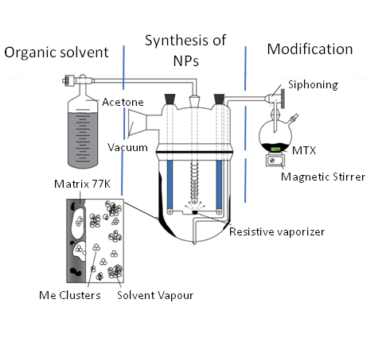

**Scheme S1.** Synthesis of the metal nanoparticles modified with methotrexate.

Results and discussion



**Figure S1.** Au 4f7/2 XPS spectra of AuFeTol and AuFeAc. To show the differences between AuFeTol and AuFeAc nanoparticles, the spectra were reduced to the same binding energy.



**Figure S2.** XPS Au 4f7/2 spectra of AuFeTol, AuFeTolMTX and Au foil.



**Figure S3.** Au 4f7/2 XPS spectra of AuFeAc, AuFeAcMTX and Au foil.

The Au foil peak is shifted by 0.3 eV towards high binding energies to visually  
show the similarity of the spectra of the AuFeAc sample and the foil.

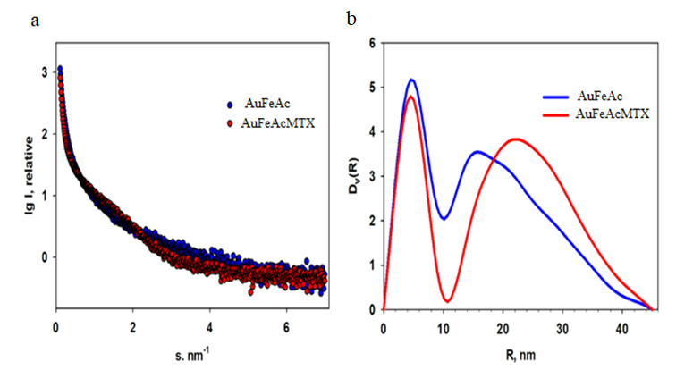

**Figure S4.** SAXS curves of the AuFe nanoparticles obtained in the acetone medium, as well as their conjugates: experimental SAXS curves (***a***), volume size distribution functions *D*v*(R)* (***b***)*.*

**Table S1.** Concentrations of the elements on the surface of the studied samples (at %)  
calculated from the high-resolution XPS spectra

|  |  |  |  |  |  |
| --- | --- | --- | --- | --- | --- |
| **Sample** | **Au** | **Fe** | **O** | **C** | **N** |
| MTX |  |  | 13.3 | 69.3 | 17.4 |
| AuFeTol | 2.9 | 26.2 | 41.1 | 29.8 |  |
| AuFeTolMTX | 1.0 | 6.4 | 16.5 | 73.4 | 2.7 |
| AuFeAc | 12.0 | 14.5 | 25.8 | 47.8 |  |
| AuFeAcMTX | 25.9 | 8.1 | 21.7 | 65.4 | 3.7 |

Thus, based on the XPS data, the formula AuFe6.4C73.4O16.5N2.7 was assigned to the AuFeTolMTX sample, and the proportion of methotrexate in the sample was 11.5 wt %. The formula Au25.9Fe8.1C65.4O21.7N3.7 corresponds to the AuFeAcMTX sample, the mass fraction of methotrexate was 4.1 wt %.

**Table S2.** Antibacterial activity of the samples

|  |  |  |
| --- | --- | --- |
| **Sample** | **Bacterial growth suppression zone (mm)** | |
| *Escherichia coli* | *Bacillus cereus* |
| AuFeAc | 6.7 (±0.2) | 7.5 (±0.3) |
| AuFeTol | 6.3 (±0.4) | 7.5 (±0.9) |
| AuFeAcMTX | 7.7 (±0.2) | 8.3 (±0.1) |
| AuFeTolMTX | 7.2 (±0.2) | 7.0 (±0.3) |
| Control | 42.0 (± 1.8) | 35.5 (± 1.3) |

**References**

S1. A. Vasil'kov, A. Voronova, T. Batsalova, D. Moten, A. Naumkin, E. Shtykova, V. Volkov, I. Teneva, B. Dzhambazov, Materials, **2023**, 16, 3238. DOI: 10.3390/ma16083238